Text 325_Jacobi Papers **Jacobi**

[**Jacobi Papers**](https://www.iijg.org/resources/jacobi-papers/) | **Monographs |** **Manuscripts |** **Absolute Generations | Man and his Work |**[**Jacobi Library**](https://www.iijg.org/resources/jacobi-library/)**| In Memoriam**

# Jacobi Papers

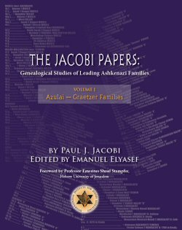***The Jacobi Papers: Genealogical Studies of Leading Ashkenazi Families (4 vols)***

***by Paul J. Jacobi  
edited by Emanuel Elyasaf***

Paul J. Jacobi (Könisberg, 1911 - Jerusalem, 1997) was a doyen of Jewish genealogy in his time. He spent half a century meticulously investigating the lineages of leading Ashkenazi, mainly rabbinic, families. These erudite volumes are the product of his labours. Running to 2,298 pages in all, and containing countless family trees going back many centuries, they are a cornucopia of genealogical knowledge and data of relevance to all family historians and scholars working on Ashkenazi Jewry. General readers should check the ***Surname Index*** for mentions of their specific families.

Jacobi held that a core-group of some 80 élite families dominated Ashkenazi Jewry from its beginnings. To test his theory, he investigated over 450 families to varying levels of detail, using the considerable resources available to him in Jerusalem. Of these, he took over 100 studies to completion. None of his researches, however, was published during his lifetime. On his death, his manuscripts were placed in the National Library of Israel. Two decades later, this invaluable genealogical compendium, Jacobi’s life-work, is being published for the first time.

**About the Author**

Paul Jacobi came to Eretz Israel/Palestine in 1919. He trained as a lawyer in Germany and England and was called to the Palestine Bar in 1936. During World War 2 he was a member of the Haganah. Involved in multiple public activities and also active in local politics, he ran unsuccessfully for Mayor of Jerusalem in 1965.

A polymath, Jacobi’s deepest passion was for Jewish history and, in particular, for Jewish genealogy. He was a founding member of the Palestine Jewish Genealogical Society when it was formed in 1937, and enjoyed international renown as an expert in his speciality, the genealogical origins of Ashkenazi Jewry.

Click here to purchase volumes.

Click here to view Title Page and Table of Contents

Click here to view Surname Index and Short Index